Annexe 1 : Matrice de Denison & Mishra
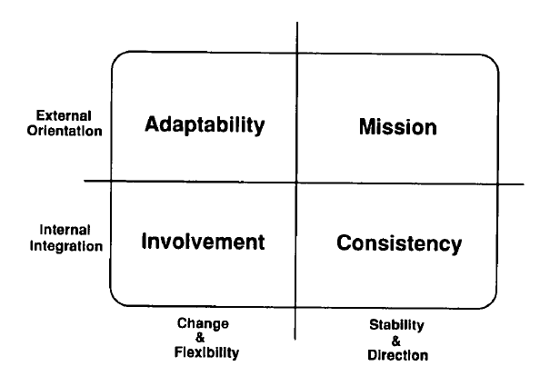
Figure 5 : Denison & Mishra (1995), Toward a theory of organizational culture and effectiveness

