Appendix file for GestureCards containing GIFs.

Table of contents
I Figure 60 in main report: "CrossHandsNo using a GIF". 1
II Figure 61 in main report: "Gesture "Jump" with a GIF". 1
III Figure 63 in main report: “SwipeRight while driving a car”. 1
IV Table 4 in main report: “Gestures shows and their corresponding literal description for the study”. 2
V Figure 71 in main reportArmElevation's gesturecard with a longer delay on the last frame. 3

Figure 60 in main report: "CrossHandsNo using a GIF".
CrossHandsNo |  | Multiplicity: 3

Figure 61 in main report: "Gesture "Jump" with a GIF".
Jumping | 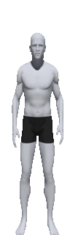

Figure 63 in main report: “SwipeRight while driving a car”.
SwipeRight | 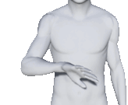 | Speed: Fast
Context: Driving  Modality: Car screen |  | Speed

Table 4 in main report: “Gestures shows and their corresponding literal description for the study”.
 | Gesturecard | Literal description
1 | 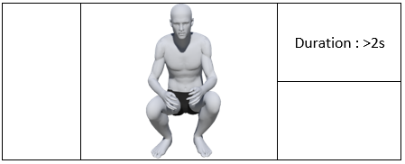 | Crouched position
2 |  | Arm elevation
   | 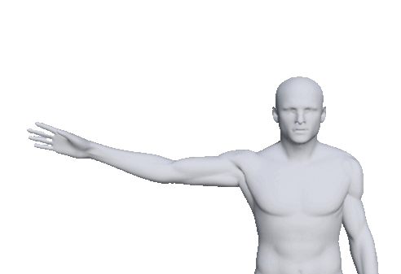 | Tool: RightArm
   |  | Location
3 |  | Draw a circle with the palm
   | 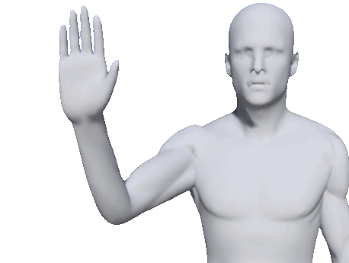 | Tool: HandPalm
   |  | Location, Speed
4 |  | Jumping
  Position
5 |  | Saying no with two hands
  Repetition: 2
6 | 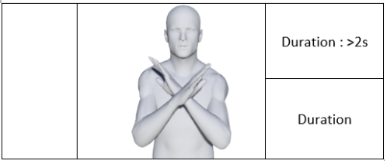 | Crossed arms in X
7 |  | Draw an X with a finger
   | 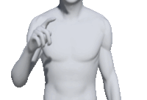 | Tool: FingerIndex
   |  | Location, Speed
8 | No corresponding card | Bent over position
9 | No corresponding card | Draw a square with a finger
10 | No corresponding card | Hand sweep to the right
11 | No corresponding card | Standing up
12 | No corresponding card | Crossed arms

Figure 71 in main report: “ArmElevation's gesturecard with a longer delay on the last frame”.
ArmElevation |  | Tool : RightArm
ArmElevation |  | Location

